*Week 6: Playtesting*

## Premise of the game

The team is tasked to choose a game from the given list and playtest on it. The game chosen by the team is titled “The Great Flu”.

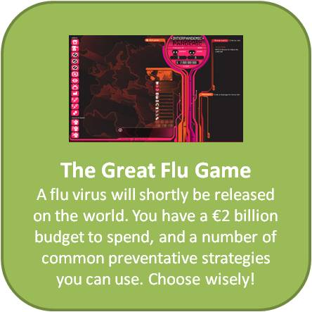

*Figure 1: Brief description on “The Great Flu” game*

## Game of choice and why

This game was chosen as it ties in with the current condition of our world as we are also facing the pandemic of Covid-19. Addressing the situation further and to acknowledge how it is very severe and we need to do what we can to contain it.

## Goal of the game

The goal of the game is to contain a pandemic that the player has unleashed onto the world with a $2 billion budget. To achieve this, the player must strategize their public health moves in order to win the game. Once the pandemic has been neutralized, the player wins the game.

## Playtesting

It would have been beneficial if the team could have play-tested the game. However, this was not viable as the game is no longer in stores to access and therefore, resulted in the team taking what they can from the video provided. To add to that, there was only 2 videos (Part 1 & 2) on YouTube which the team took referencing from. Each member of the team reviewed the gameplay video and noted down each aspect of the game that could be found. This was a difficult task as their was no commentary and the player was playing blindly. Below is a link that was provided to view the game:

<https://www.youtube.com/watch?v=9a3bSlQLpnI&ab_channel=torteman54>

## Questionnaire and responses

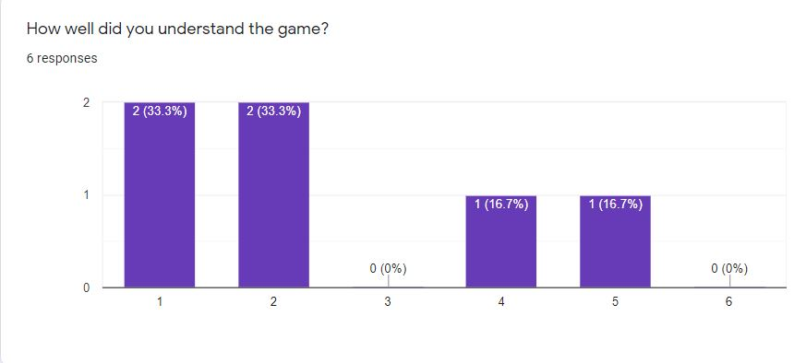*Figure 1.1: Bar chart showing the percentages of how well players understood the game*

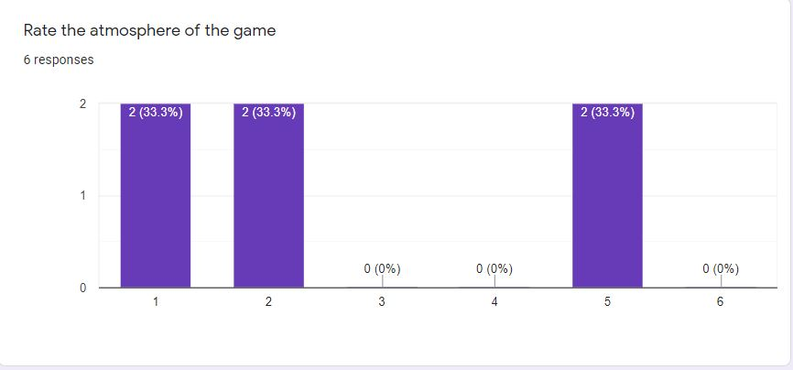*Figure 1.2: Bar chart indicating the percentages of the atmosphere of the game*

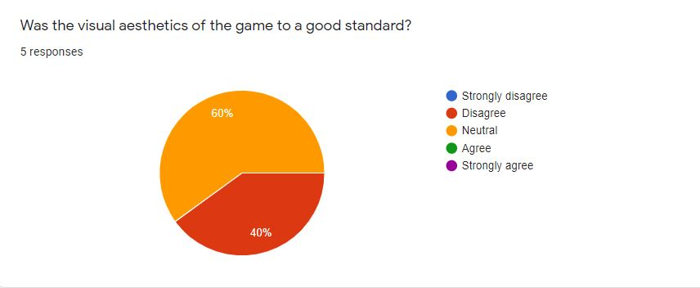

*Figure 1.3: Pie chart displaying the percentages of how well the aesthetics of the game were*

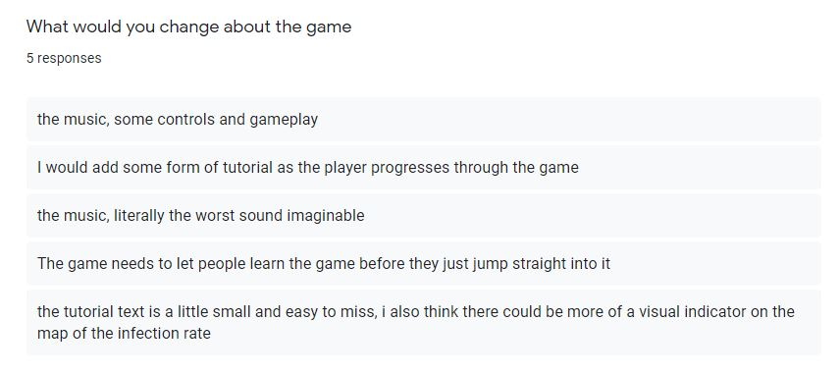*Figure 1.4: Responses from players on the changes they would make to the game*

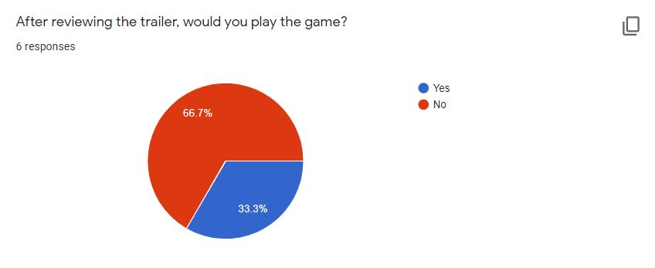

*Figure 1.5: Pe chart representing the percentages of whether players would play the game*